Name:…………………………………………..……..… signature:……………………….……



**=**

**TERM TWO CONTINUOUS ASSESSMENT, 2022**

**SENIOR TWO**

**GEOGRAPHY**

**TIME: 2 HOURS**

**INSTRUCTIONS**

* ***Answer all questions.***

1. Last year in 2021, The Ministry of Agriculture in Uganda published statistics on maize production which was as follows.

|  |  |
| --- | --- |
| **Month** | 1. **metric tons** |
| Jan - March  April - June  July – September  October - December | 25000  2300  21000  37000 |

1. What is meant by the term”statistics” as being used by the Ministry of Agriculture in Uganda?
2. How did the Ministry of Agriculture in Uganda collect its statistics on maize productions as shown above?
3. State the least months of maize production in Uganda.
4. State the leading months with the maize production in Uganda.
5. Explain the reasons why the government of Uganda is encouraging its citizens to grow maize.
6. S.1 students are confused of the factors to consider before setting a weather station at school such that weather elements are properly recorded at school such as rainfall sunshine and wind.

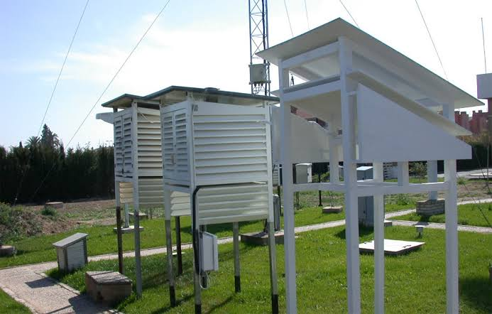

1. How can you assist S.1 students from that confusion?
2. What weather instruments can be established in their weather station and for what purpose?
3. Residents of Kyabakadde village in the Kyabakadde Millet SACCO wanted to dry their crops for two days to sell their produce to the market but after drying them outside their home compounds unfortunately they fear to be disrupted by abrupt Weather changes such as rain fall.

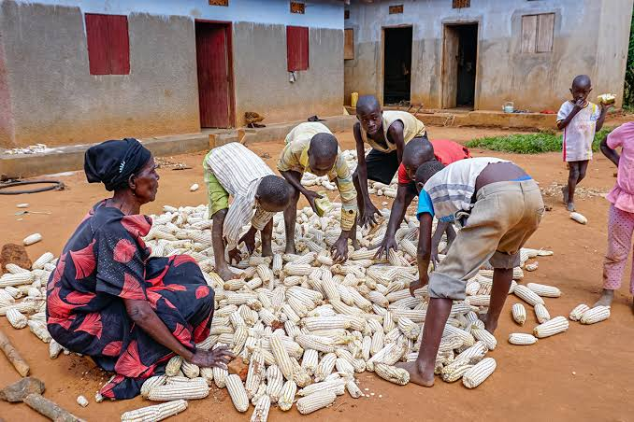

1. What traditional methods can you use to predict the weather and help the Kyabakadde Residents for that fear of abrupt weather changes?
2. How is weather prediction beneficial to farmers of Kyabakadde village?

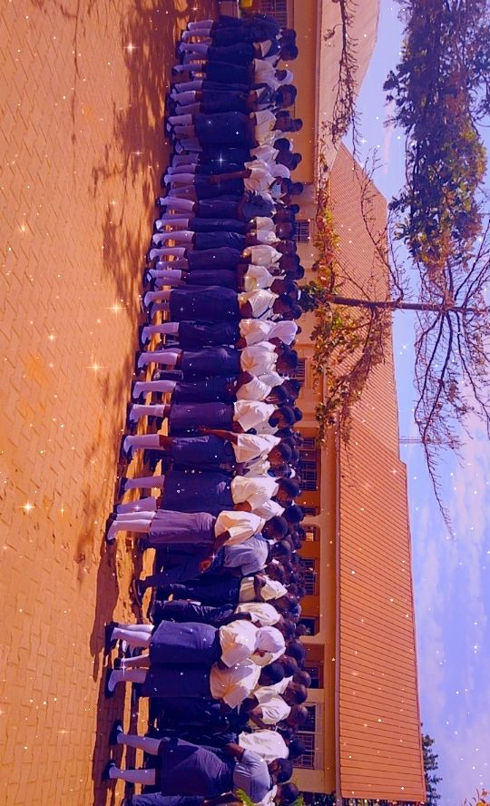

1. Masajja Selona Secondary School is expected to admit new students in senior one class next year but new comers may fail to follow the right path of reaching the school and this may cause delays in admitting the leaner’s in time.
2. How can you assist the S.1 newcomers and their parents to reach at school in time while following the Right paths?
3. The president for republic of Uganda H.E Y.K Museveni has encouraged the new by countries to join East African Community (E.A.C) due to its social benefits plus their economic benefits.

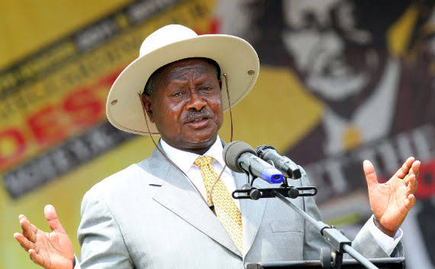

1. What is meant by E.A.C as being used by the President of Uganda H.E.Y.K. Museveni?

1. List the countries in the E.A.C.
2. What are the economic and social benefits these countries are benefiting for the E.A.C.?
3. What are the likely problems to be faced by the new members joining East Africa Community?

**END.**